Digital Loan origination portal for NBFC

Document | Details | Document | Details
Version | 1.0 (Draft for review) | Prepared by | Business Analyst
Client | NBFC (Personal Loans) | Amruta S L | For stakeholder sign-off

INDEX
SR.NO | TITLE | PAGE.NO
1 | Business Context and Problem Statement | 2
2 | Objectives and Scope | 2
3 | Stakeholders | 3
4 | Assumptions and Constraints | 3
5 | High-Level Business Requirements | 4
6 | Functional Specification – Key Use Cases | 5-6
7 | Process Flow Diagram | 7
8 | Annexure – Low-Fidelity Mockups | 8-9

1. Business Context and Problem Statement
The NBFC offers unsecured personal loans through branches and sales agents. Applications are captured on paper forms, KYC documents are couriered or scanned by staff, and credit and operations teams track files through spreadsheets and email. The client wants to move the customer journey online and give internal teams a single, secure system of record.
Problem statement: The current manual process causes long turnaround times (TAT), high drop-off, data-entry errors, weak audit trails, and no real-time status visibility for customers. This limits scalability and increases compliance risk under RBI Digital Lending and KYC norms.
Current pain point | Business impact
Paper-based application and KYC | Slow onboarding; re-keying errors; document loss
No status visibility for customers | High call volume to support; poor customer experience
Email/spreadsheet-based approvals | No SLA tracking, weak audit trail, key-person dependency
Manual credit and KYC checks | Inconsistent decisions; longer TAT; higher cost per loan

2. Objectives and Scope

2.1 Business objectives
- Reduce application-to-decision TAT from days to under 24 hours for straight-through cases (target to be baselined).
- Increase digital share of new applications and reduce application drop-off through a simple, mobile-friendly journey.
- Reduce manual effort and errors through OCR, auto-validation and rule-based pre-screening.
- Ensure regulatory compliance and auditability (RBI KYC, Digital Lending Guidelines, data privacy).
- Give customers real-time transparency through status tracking and automated notifications.

2.2 Scope
In scope (Phase 1) | Out of scope (Phase 1)
Customer web/mobile-responsive portal: registration, application, KYC upload, status tracking | Other products (home, gold, business loans)
Back-office portal for credit and operations: queues, review, approval/rejection, remarks | Collections and post-disbursement servicing
Automated notifications (SMS, email, push) at key stages | Full core lending system (LMS) replacement
Integrations: KYC/e-KYC, credit bureau, SMS/email gateway, e-sign, LMS handoff | Co-lending and partner/DSA portals
Role-based access, audit logs, MIS dashboards and reports | Native mobile apps (responsive web only)

3. Stakeholders
Stakeholder | Role / interest | Involvement
Business Sponsor (Head – Retail Lending) | Owns outcomes: growth, TAT, cost | Approves scope, budget, BRD sign-off
Customers / Applicants | Fast, simple, transparent loan process | UAT feedback; primary end users
Credit Team (Analysts, Managers) | Assess risk, approve or reject loans | Define credit rules and approval matrix; UAT
Operations Team | KYC verification, documentation, disbursal | Define process and SLAs; UAT
Compliance and Risk | RBI/KYC/data-privacy adherence | Review requirements; audit sign-off
IT / Vendor Team, InfoSec | Build, integrate, secure and host the platform | Solution design, NFRs, security testing
Customer Support | Handle queries and escalations | Status/notification content; training

4. Assumptions and Constraints

Assumptions
- Customers are Indian residents aged 21–60 with a valid PAN, Aadhaar and bank account; loan range and tenure per current product policy (e.g. ₹50,000–₹15,00,000; 12–60 months).
- Credit policy, scorecard and approval matrix will be supplied by the Credit team and can be configured without code changes.
- Third-party APIs (e-KYC, credit bureau, e-sign, SMS/email gateway, payment/penny-drop) are available under commercial agreements.
- The NBFC’s existing LMS/core system can accept approved-loan data via API or file for disbursal and booking.
- Business users will be available for requirements workshops, UAT and training.

Constraints
- Must comply with RBI KYC Master Direction, Digital Lending Guidelines, IT Act and applicable data-protection law; customer consent and data-storage rules apply.
- Customer PII and documents must be encrypted in transit and at rest; hosting within India.
- Go-live target and budget are fixed by the sponsor (to be confirmed); phased release is acceptable.
- Phase 1 covers personal loans only; system must support future product extension.

5. High-Level Business Requirements
ID | Area | Requirement
BR-01 | Registration / login | Customers register and log in using mobile number + OTP; sessions time out securely.
BR-02 | Online application | Customers can complete a multi-step application (personal, employment, income, loan amount/tenure) with real-time validation, EMI calculator and save-and-resume.
BR-03 | Consent | System captures explicit, time-stamped consent for KYC, bureau pull and terms before submission.
BR-04 | KYC upload | Customers upload PAN, Aadhaar/address proof, income proof and photo (PDF/JPG/PNG, size limits); system runs OCR and PAN/Aadhaar verification via e-KYC APIs.
BR-05 | Auto pre-screening | System pulls credit bureau data and applies configurable eligibility rules to auto-reject or route applications.
BR-06 | Back-office queues | Credit and operations users see role-based work queues with filters, SLA ageing and document viewer.
BR-07 | Approval workflow | Credit users can approve, reject or refer back with mandatory remarks; approval limits follow a configurable authority matrix (maker-checker for high values).
BR-08 | Offer and e-sign | On approval, system generates a sanction letter/offer; customer accepts and e-signs the loan agreement.
BR-09 | Status tracking | Customers view real-time application status (Submitted, KYC pending, Under review, Approved, Rejected, Disbursed).
BR-10 | Notifications | Automated SMS/email/push at key events (submitted, deficiency, approved, rejected, disbursed) using templates.
BR-11 | Disbursement handoff | Approved and accepted loans are passed to LMS/bank for disbursal; status is reflected back.
BR-12 | Security and audit | Role-based access, MFA for staff, complete audit trail of every action, data masking of PII.
BR-13 | MIS and reporting | Dashboards for funnel, TAT, approval rate, rejection reasons and pending queues; export to Excel/CSV.
BR-14 | Non-functional | Availability ≥ 99.5%; page response < 3 sec; support for ~500 concurrent users; scalable and browser/mobile responsive; WCAG-aligned accessibility.

6. Functional Specification – Key Use Cases
Four core use cases are detailed below. Numbers in brackets refer to the high-level requirements in Section 5.
UC-01: Loan Application Submission by Customer
Actor(s) | Primary: Customer. Secondary: SMS/OTP gateway, Credit bureau API.
Pre-conditions | Customer has a valid mobile number and internet access; loan product is active.
Main flow | 1. Customer opens the portal and logs in or registers using mobile OTP.  2. System displays the multi-step application form and EMI calculator.  3. Customer enters personal, employment, income, and loan amount/tenure details.  4. System validates fields in real time (PAN format, age, min income, amount limits) and auto-saves a draft.  5. Customer reviews the details and accepts consent and terms.  6. Customer submits; system creates a unique Application ID and moves the status to ‘Submitted’.  7. System triggers bureau pull and pre-screening and shows the next step (upload KYC).
Alternate / exception flows | A1: Invalid or missing data – inline error, submission blocked. A2: Session timeout or drop – draft is saved and can be resumed. A3: Existing active application for the same PAN – system blocks duplicate and shows current status. A4: Bureau API unavailable – application queued and retried; customer informed.
Post-conditions / outcome | Application is stored with status ‘Submitted’, consent logged, confirmation notification sent to the customer.

UC-02: KYC Document Upload and Verification
Actor(s) | Primary: Customer. Secondary: Operations Executive, e-KYC/OCR service.
Pre-conditions | Application is submitted; customer is logged in; KYC checklist is generated for the customer’s profile.
Main flow | 1. System shows the required document checklist (PAN, address proof, income proof, photo).  2. Customer uploads each document (PDF/JPG/PNG within size limit) or authorises DigiLocker/Aadhaar e-KYC.  3. System validates file type/size and runs OCR to extract key fields.  4. System cross-checks extracted data against application data and verifies PAN/Aadhaar through APIs.  5. Documents that pass go to the Operations queue for verification; Operations Executive reviews and marks each document ‘Verified’.  6. When all mandatory documents are verified, KYC status changes to ‘Verified’ and the file moves to the Credit queue.
Alternate / exception flows | A1: Unreadable or wrong file – customer prompted to re-upload. A2: Data mismatch (e.g. name/DOB) – flagged for manual review. A3: Deficiency – Operations marks ‘Rejected – re-upload’ with reason; customer is notified and status becomes ‘KYC Pending’. A4: Documents not received in 7 days – reminder sent; application auto-closed after configured period.
Post-conditions / outcome | All mandatory KYC documents are stored securely and verified; audit log records who verified what and when.

UC-03: Loan Approval by Credit Team
Actor(s) | Primary: Credit Analyst / Credit Manager. Secondary: Rule engine, LMS.
Pre-conditions | KYC is verified; bureau report and pre-screening result are available; user is authenticated with the Credit role.
Main flow | 1. Credit Analyst opens ‘My Queue’ and selects an application (sorted by SLA ageing).  2. System displays applicant profile, documents, bureau score, FOIR/DTI, rule results and suggested decision.  3. Analyst assesses risk and selects Approve, Reject or Refer back, entering mandatory remarks.  4. For approvals: system checks the approval authority matrix; if the amount exceeds the analyst’s limit, it routes to the Credit Manager (maker-checker).  5. System records the decision, sanctioned amount, rate and tenure, and generates the offer/sanction letter.  6. System updates the status to ‘Approved’ (or ‘Rejected’ with reason code) and triggers the customer notification (UC-04).
Alternate / exception flows | A1: Additional information needed – ‘Refer back’ sends the file to Operations/customer with a query. A2: Analyst attempts to approve above limit – system escalates. A3: Same user cannot maker and check the same file. A4: Rejection requires a standard reason code (policy, bureau, income, KYC).
Post-conditions / outcome | Decision is final and auditable; approved case is ready for customer acceptance and e-sign, then disbursal handoff.

UC-04: Status Notification to Customer
Actor(s) | Primary: System (notification engine). Secondary: Customer, SMS/email/push gateways.
Pre-conditions | Application exists; customer contact details are verified; notification templates are configured and approved (including DLT-registered SMS templates).
Main flow | 1. A status-change event occurs (Submitted, KYC deficiency, Approved, Rejected, Disbursed).  2. Notification engine selects the template and channels based on event and customer preference.  3. System populates the template (name, Application ID, status, next action, reason for rejection where allowed).  4. System sends SMS, email and/or push notification and logs delivery status.  5. Customer opens the portal and views the updated status on the tracking screen.
Alternate / exception flows | A1: Delivery failure – retry with fallback channel (e.g. SMS to email); after retries mark ‘Failed’ and alert Operations. A2: Customer has opted out of promotional messages – transactional messages are still sent. A3: Duplicate event – de-duplicated within a set window.
Post-conditions / outcome | Customer is informed within minutes of each status change; every notification and delivery result is logged.

7. Process Flow Diagram
The swimlane below shows the end-to-end personal loan journey across the customer, the system, the operations team and the credit team. Steps 1–3 map to UC-01/UC-02, steps 7a–7b to UC-02/UC-03 and step 8 to UC-04.
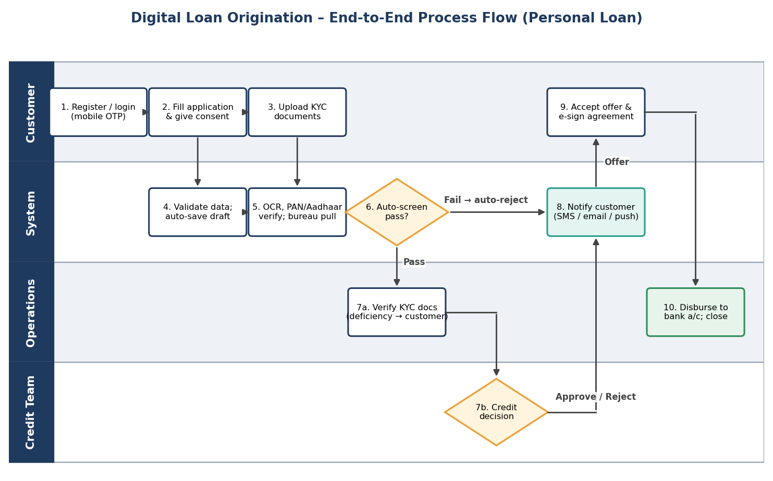
Figure 1: Digital loan origination – swimlane process flow
Key rules shown: (a) applications failing auto-screening are rejected instantly with a reason and a notification; (b) KYC deficiencies loop back to the customer; (c) credit approvals beyond a user’s limit escalate to a manager; (d) disbursal happens only after the customer accepts the offer and e-signs.

8. Annexure – Low-Fidelity Mockups

Mockup 1: Customer loan application form (Step 1 of 5)
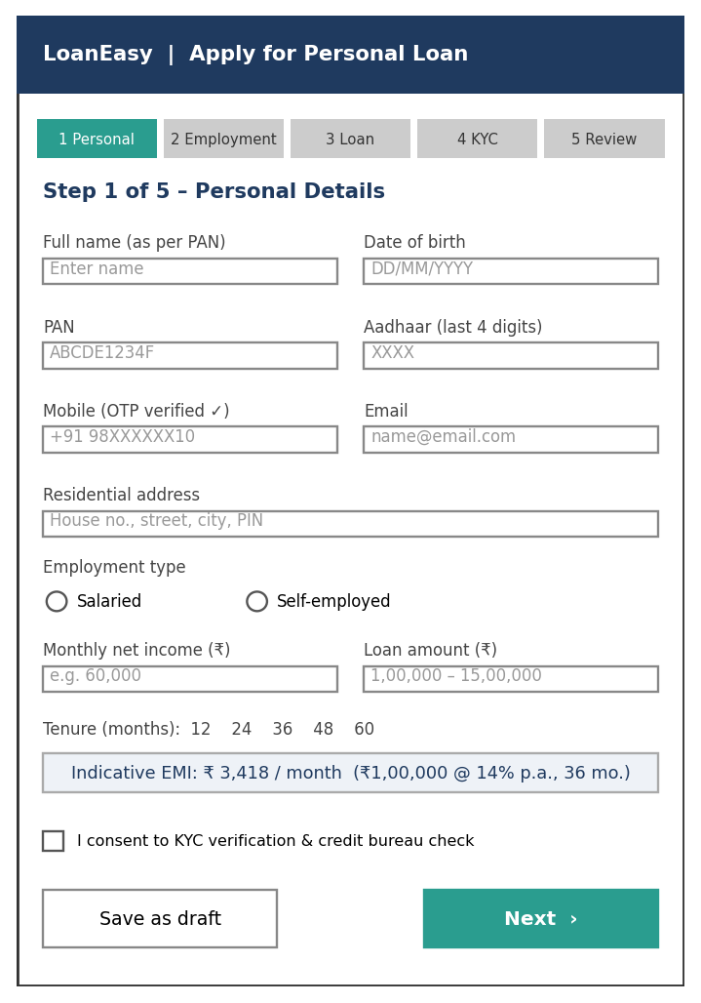
Figure 2: Customer application form wireframe (mobile-responsive)

Mockup 2: Credit team back-office dashboard
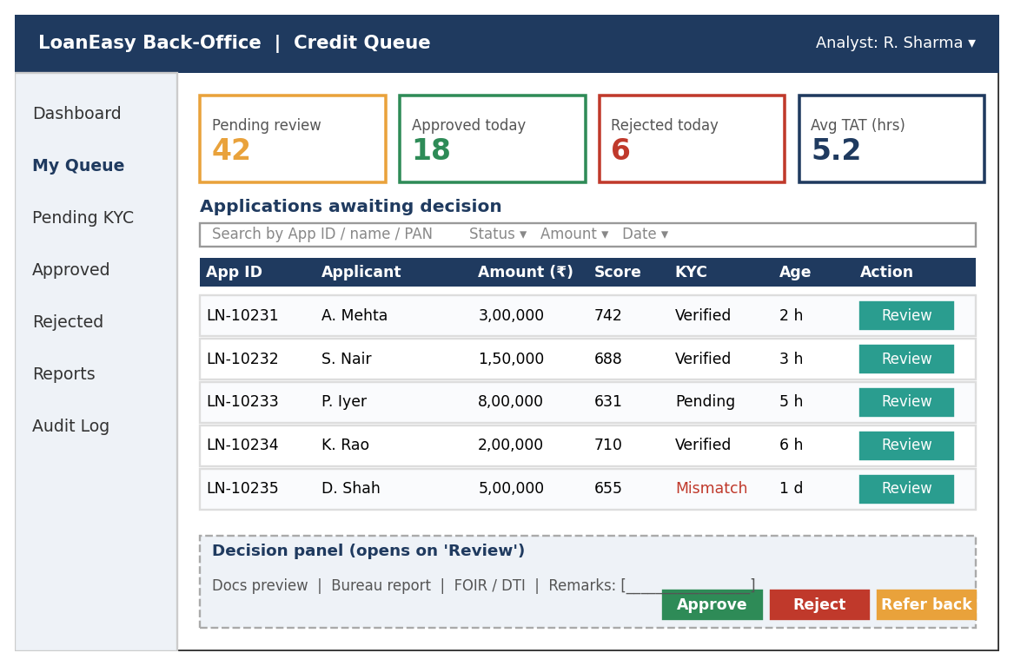
Figure 3: Credit queue and decision panel wireframe

Open points for stakeholder confirmation
- Final loan limits, tenure and interest-rate slabs, and the credit approval authority matrix.
- Choice of KYC/e-sign/bureau vendors and whether video-KYC is required in Phase 1.
- Target TAT, expected volumes and go-live date for capacity planning and phasing.

